INTRODUCTION:

Here’s a short and simple summary of that long section you gave me:

- 🚗 Problem: Rapid growth of vehicles causes congestion, accidents, and energy issues. Building more roads is not enough.
- 🛰 Solution: Intelligent Transportation Systems (ITS) use real-time data to manage traffic more efficiently.
- 🐜 Ant Colony Optimization (ACO): Inspired by ants’ foraging, good for path planning, but has slow convergence and local optima issues.
- 🔬 Past Work: Many improvements of ACO (ε-greedy, Levy flight, dual-layer ACO, etc.) and ITS research (deep learning, IoT, reinforcement learning).
- ⚠ Gap: Existing methods lack adaptability and full optimization in complex traffic.
- 💡 Innovation (RA-GA-ACO): Combines Genetic Algorithm (global search) + ACO (local search) + Reward & Punishment strategy.
- ✅ Contributions:
  - Faster, more accurate, and stable path planning.
  - Avoids premature convergence.
  - Uses crossover + smoothing to boost optimization.
- 📌 Impact: Improves traffic flow, reduces congestion, saves resources, and provides a strong solution for ITS.

👉 Do you want me to make this even shorter (3–4 lines for a presentation slide)?
Result
Perfect 👍 Thanks for sharing the full section.
It’s a bit long and math-heavy, so I’ll compress it into short, clear, and necessary points for you.

🚦 Path Planning in ITS (Intelligent Transportation Systems)

1. Why do we need it?
- Traffic congestion is a big issue.
- Optimal Path Planning (OPP) → improves efficiency, reduces travel time, and avoids jams.

2. ACO (Ant Colony Optimization)
- Inspired by ants finding food using pheromones.
- Ants choose paths with higher pheromone concentration → eventually shortest/best path is reinforced.
- Problems with ACO:
  - Converges slowly.
  - Can get stuck in a local best solution, not the global best.

3. GA (Genetic Algorithm)
- Inspired by natural evolution.
- Uses selection, crossover, mutation to improve solutions.
- Helps escape local optima and explore widely.

4. GA–ACO (Combination)
- Idea: use GA + ACO together.
- Workflow:
  - GA quickly generates good initial solutions.
  - These are converted into initial pheromones for ACO.
  - ACO refines and searches for the best path.
  - Fusion timing between GA & ACO is dynamic → improves accuracy and avoids stagnation.

5. VCP Model (Vehicle Routing Problem)
- Real-world scenario: vehicles must deliver to multiple customer points.
- Must find the shortest path visiting all points while avoiding congestion.
- GA–ACO is applied here.

6. RA–GA–ACO (Improved version)
- Adds a Reward–Punishment Strategy:
  - Reward → good/feasible paths get higher pheromones.
  - Punishment → bad/invalid paths lose fitness, reducing chance of selection.
- Other improvements:
  - Smoothing mechanism → avoids sudden jumps in pheromone updates.
  - Diffusion mechanism → pheromone spreads in a radius to explore nearby paths.
  - Max–min ant strategy → prevents premature convergence.

7. How it runs (short workflow)
- Initialize parameters (pheromones, ants, GA population).
- Run GA → generate initial solutions with crossover & mutation.
- Convert GA solutions → pheromone matrix for ACO.
- Run ACO → ants move based on transition probability, updating pheromones.
- Reward/Punishment applied → good solutions reinforced, bad ones penalized.
- Iterate until best global path found.

8. Key Takeaway
- ACO alone → slow & may get stuck.
- GA–ACO → faster & better exploration.
- RA–GA–ACO → smartest version:
  - Adapts to real-time traffic.
  - Avoids congestion.
  - Finds shortest, feasible, efficient paths in complex traffic networks.
👉 In short: RA–GA–ACO = Intelligent, adaptive, and efficient path planning for smart transportation systems.

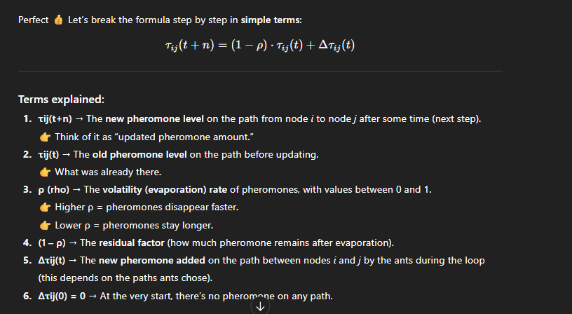

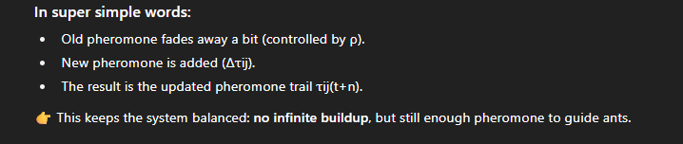

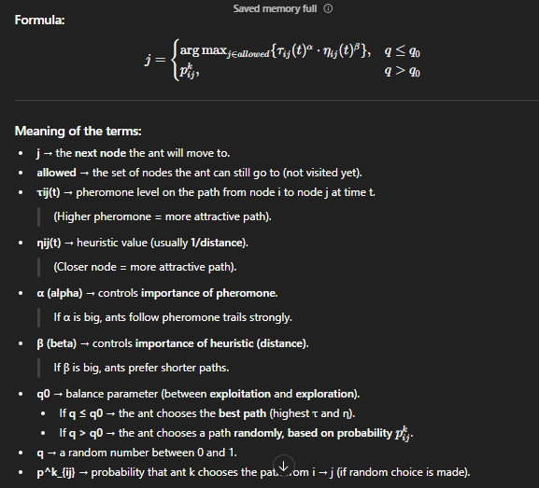

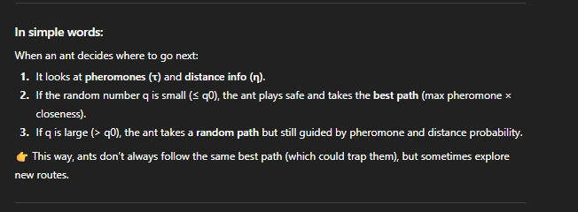

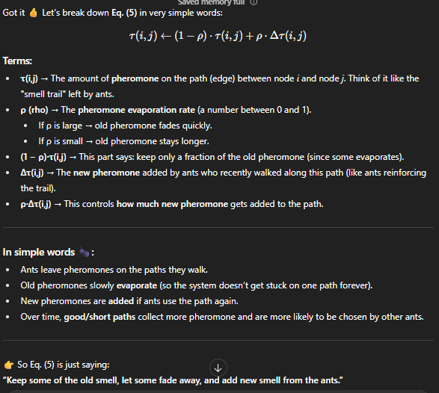

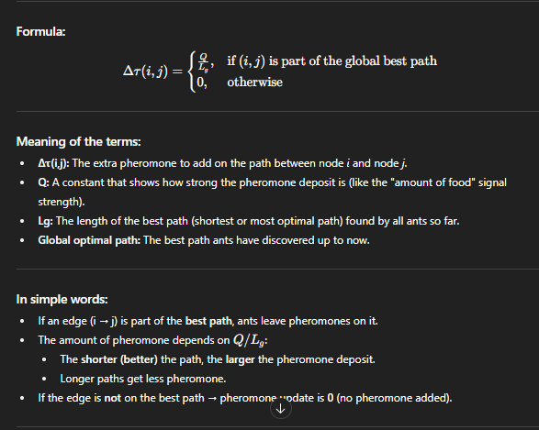

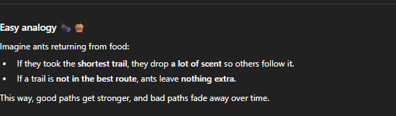

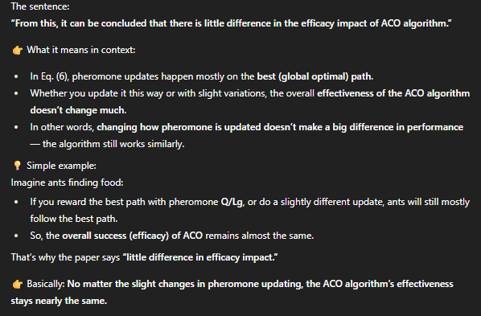

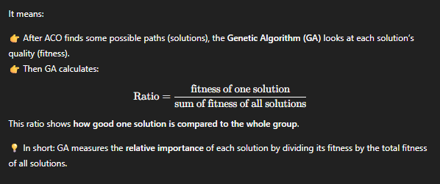

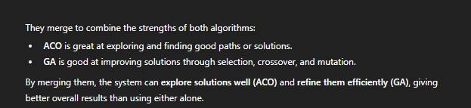
Got it 👍 Let’s simplify this huge chunk step by step so it’s clear and easy to understand. I’ll keep only the important equations and ideas without the heavy math jargon.

🔹 Key Idea
The GA–ACO hybrid algorithm (Genetic Algorithm + Ant Colony Optimization) is used for path planning (finding the best/shortest path).
- GA part helps generate new candidate solutions (by crossover + mutation).
- ACO part helps refine these solutions using pheromone trails (like how ants find food).
- Together, they balance exploration (search widely) and exploitation (improve good paths).

🔹 Step 1: Fitness with Penalty
If a solution follows constraints:
F′(x)=F(x)F'(x) = F(x)
If it violates constraints:
F′(x)=F(x)⋅P(x)F'(x) = F(x) \cdot P(x)
👉 Here, P(x)P(x) is a penalty to reduce fitness of invalid solutions.

🔹 Step 2: Crossover (GA Part)
Two parents P1 and P2 are selected.
A sub-path qq is chosen from their intersection, and the best path segments are kept.
Equation (10):
A={q1∣L(q)=Lmin⁡,∣q∣=f(t)}A = \{q_1 \mid L(q) = L_{\min}, |q| = f(t)\}
👉 Meaning: Choose the shortest sub-paths at iteration tt.
Equation (11):
f(t)=min⁡(⌊t2n+2⌋,n2)f(t) = \min\left(\Big\lfloor \frac{t}{2n}+2 \Big\rfloor , n^2\right)
👉 This decides how many midpoints to keep based on iteration count tt and population size nn.

🔹 Step 3: Initial Pheromone (ACO Part)
After GA generates good paths, these are used to set pheromone values:
τijS(0)=τC+τijG(0)\tau_{ij}^S(0) = \tau_C + \tau_{ij}^G(0)
👉 Constant + pheromone converted from GA results.
Equation (13) for pheromone limits:
τmax⁡(t)=12(1−p)⋅1L(Sbest)+1L(Sbest),τmin⁡(t)=τmax⁡(t)20\tau_{\max}(t) = \frac{1}{2(1-p)} \cdot \frac{1}{L(S_{best})} + \frac{1}{L(S_{best})}, \quad \tau_{\min}(t) = \frac{\tau_{\max}(t)}{20}
👉 Here L(Sbest)L(S_{best}) is the best path length, pp = evaporation factor.

🔹 Step 4: Smoothing Mechanism
To avoid premature convergence, pheromone values are smoothed:
τij∗(t)=τij(t)+δ(τmax⁡(t)−τij(t))\tau^*_{ij}(t) = \tau_{ij}(t) + \delta \big(\tau_{\max}(t) - \tau_{ij}(t)\big)

🔹 Step 5: Reward & Punishment (Diffusion)
If ants choose a good path: reward pheromone.
If not: penalize or reduce pheromone.
Equation (15):
kij(t)={λQLk(1dijr),dij<r0,otherwisek_{ij}(t) = \begin{cases} \frac{\lambda Q}{L_k}\Big(\frac{1}{d_{ij}^r}\Big), & d_{ij}<r \\ 0, & \text{otherwise} \end{cases}
👉 Where dijd_{ij} is distance between nodes, rr = diffusion radius, λ<1\lambda < 1.

🔹 Step 6: Iterative Process (Algorithm Flow)
- Initialize parameters (pheromone, population, etc.).
- Run GA → compute fitness, select, crossover, mutate → get new population.
- Convert GA results → initial pheromone for ACO.
- Run ACO → ants build paths based on pheromone probability.
- Find shortest path in each iteration.
- Update global pheromone (reward best paths, punish bad ones).
- Repeat until convergence.

✅ In short:
- GA generates strong candidate solutions.
- ACO refines them using pheromone trails.
- Together, RA-GA-ACO finds the optimal path faster and avoids getting stuck.

Do you want me to also make a simple diagram/flowchart so you can quickly visualize this step-by-step process?
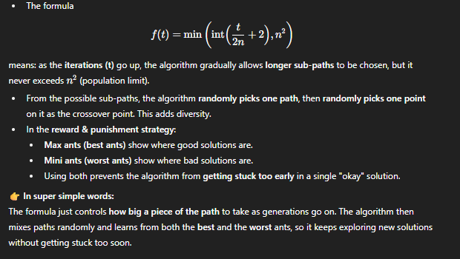

Result

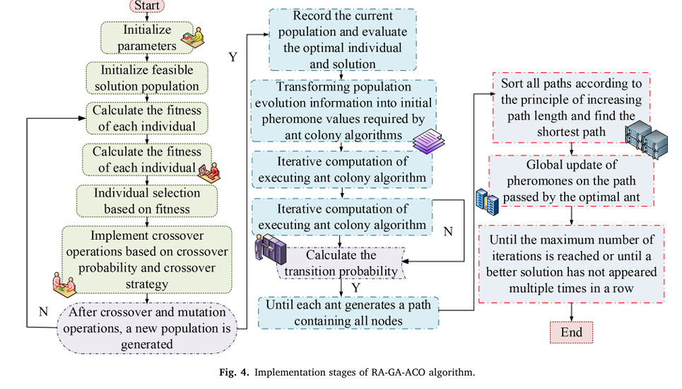

🧠 Short Summary of Implementation Steps
- Initialize Parameters Set required values for ACO (pheromone factors, heuristic parameters, etc.).
- Run Genetic Algorithm (GA)
  - Evaluate fitness of individuals
  - Apply crossover and mutation
  - Generate new population
- Select Optimal Individual Convert best GA solution into initial pheromone matrix for ACO.
- Run ACO Iterations
  - Ants move based on transition probabilities
  - Shortest path is identified
  - Optimal ant is selected
- Update Global Pheromones Reinforce the path taken by the best ant to guide future iterations.

⚙️ What It Means
This hybrid model uses GA for global exploration and ACO for local refinement. GA finds promising solutions quickly, and ACO fine-tunes them by simulating ant behavior to discover the shortest path. The pheromone update ensures that good paths are reinforced over time, improving convergence.
- The study tested ACO, GA, and GA-ACO on city path planning.
- GA-ACO was faster (34s vs 45s & 116s) and found shorter paths (14,578 vs 15,940 & 15,758).
- It avoids getting stuck, converges faster, and uses fewer computer resources.
Comparison results:
- GA-ACO had higher accuracy, robustness, and stability than ACO in different road conditions.
- It also used less CPU (32% vs 48%) and less memory (37% vs 56%), and ran faster (0.21s vs 0.35s).
With real delivery problem (VRP test):
- RA-GA-ACO gave shorter paths (99.2 km vs 109.6 km with ACO).
- It also needed fewer iterations (36 vs 49) and less time (8.45s vs 9.16s).
Compared with new 2024 algorithms (INOA & IACA-MS):
- RA-GA-ACO still won with shortest path, fewer iterations, and fastest time.
👉 In one line:
RA-GA-ACO is more accurate, faster, stable, and resource-efficient than ACO, GA, and even newer algorithms, making it the best choice for intelligent transportation path planning.

Application effect of intelligent transportation path planning model

- Researchers tested delivery routes using 12 delivery points, 1 center, and 5 vehicles.
- They compared ACO and the improved RA-GA-ACO algorithm.
- RA-GA-ACO gave shorter routes (99.2 km vs 109.6 km), saving 10.4 km.
- It also found results faster (8.45s vs 9.16s) and with fewer iterations (36 vs 49).
- The planned paths with RA-GA-ACO were smoother, shorter, and more efficient.
- When compared to other new 2024 algorithms (INOA & IACA-MS), RA-GA-ACO still performed best in path length, speed, and iterations.
👉 In one line: RA-GA-ACO is the most efficient and accurate algorithm for delivery route planning, beating ACO, GA, and even the latest 2024 methods.

Discussion:
The RA-GA-ACO algorithm (Reward + Genetic Algorithm + Ant Colony) was tested for traffic path planning.
It worked better than traditional ACO and GA-ACO by finding shorter paths faster, reducing congestion, saving resources, and improving traffic flow. It is similar to methods used for charging stations, drones, and bike-sharing systems. Overall, it gives accurate, real-time solutions for managing traffic in smart cities.

Conclusion:
The new RA-GA-ACO algorithm:
- Finds optimal paths quicker than ACO, GA, INOA, and IACA-MS.
- Is more stable, adaptive, and efficient.
- Reduces traffic congestion and resource use.
- Can be applied in real intelligent transportation systems.
Limitation: It does not yet handle real-world factors like traffic lights, road conditions, or emergencies.

how they collected the dataset and what ,the dataset is and how they tested the datset :

1. What is the dataset?
- The dataset is coordinates of cities or delivery points on a Cartesian plane (x, y values).
- Example: City 1 = (1280, 2132), Delivery point 1 = (9.6, 14.8), etc.
- These coordinates act as nodes where vehicles must travel — just like real cities or delivery locations in a map.

2. How did they collect it?
- The dataset was not collected from the real world; instead, they set the coordinates as examples (benchmark test cases).
- They used:
  - 16-city problem (urban transportation).
  - 12 delivery points + 1 distribution center (logistics/VRP problem).
- These coordinate datasets are standard simulation inputs for path planning research.

3. How did they test the dataset?
- They ran the algorithms (ACO, GA, GA-ACO, RA-GA-ACO) on the same dataset.
- Each algorithm tried to find the shortest/optimal path covering all nodes (like solving a traveling salesman / vehicle routing problem).
- They measured performance by checking:
  - Optimal path length (shorter = better).
  - Iterations needed (fewer = better).
  - Execution time (faster = better).
  - Stability, adaptability, robustness in different test sizes (20, 25, 30 cities).
  - CPU and memory use.

👉 In short:
The dataset is just coordinates of cities/delivery points (test cases).
They didn’t collect real traffic data — they used simulated coordinates.
They tested algorithms on these coordinates to see which finds shorter and faster routes with fewer resources.

how they simulate or find the coordinate of the cities and where they test it:

How they simulated / found the coordinates
- The city and delivery point coordinates were not collected from GPS or maps.
- Instead, they are artificially generated test datasets (benchmark-style).
- Researchers usually:
  - Choose random numbers within a certain range (e.g., 0–4000 for big cities, 0–20 for small logistics networks).
  - Assign each number pair (x, y) as the position of a city/delivery point.
  - This way, the dataset is simple, controlled, and repeatable.
- Example: City 1 = (1280, 2132), City 2 = (2375, 3980), Delivery Point 1 = (9.6, 14.8).
So, the coordinates are synthetic simulation data, not from real maps.

Where they tested it
- They tested the algorithms in a computer simulation environment.
- All algorithms (ACO, GA, GA-ACO, RA-GA-ACO) were coded and run on the same dataset.
- They compared results like path length, iterations, execution time, CPU/memory usage.
- The experiments were done on simulated transportation networks — basically, a virtual map made from those coordinates.

👉 In short:
The coordinates of cities/delivery points were randomly generated numbers (synthetic data) to act like map points.
The testing was done in simulation software (computer experiments), where each algorithm planned routes on that virtual map and results were compared.

Delivery Point
- A delivery point = the place where goods need to be delivered.
- Think of it as a customer’s location, shop, or house.
- In the dataset, each delivery point is shown by coordinates (x, y) on a map.
- Example: Delivery point 1 = (9.6, 14.8).

Distribution Point / Distribution Center
- A distribution point (or distribution center) = the starting hub/warehouse where all vehicles begin their trips.
- Goods are loaded here, and then vehicles travel to delivery points.
- In the dataset, there was 1 distribution center (at coordinates (13.6, 15.0)) and 12 delivery points.

👉 In short:
- Distribution center = starting hub/warehouse.
- Delivery points = customer locations where vehicles must deliver.

FULL OVERVIEW

📘 Overview of the Paper on RA-GA-ACO Algorithm for Path Planning in ITS

1. Background & Motivation
- Intelligent Transportation Systems (ITS) need efficient path planning to reduce congestion, travel time, and resource costs.
- Traditional algorithms:
  - ACO (Ant Colony Optimization) → good at finding paths using “pheromone trails”, but can get stuck in local optima (not the best solution).
  - GA (Genetic Algorithm) → strong in global search, but slow to converge.
- Solution → Combine GA + ACO with a reward & punishment strategy, called RA-GA-ACO.
- Goal: Faster, more accurate path planning.

2. Theoretical Basis

2.1 Fitness with Penalty Function (Eq. 8)
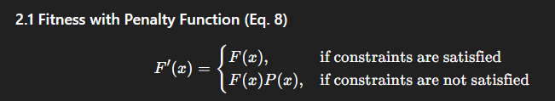
- F(x)F(x): initial fitness.
- P(x)P(x): penalty for breaking constraints.
- Ensures invalid solutions are discouraged.

2.2 Heuristic Crossover in GA (Eq. 9–11)
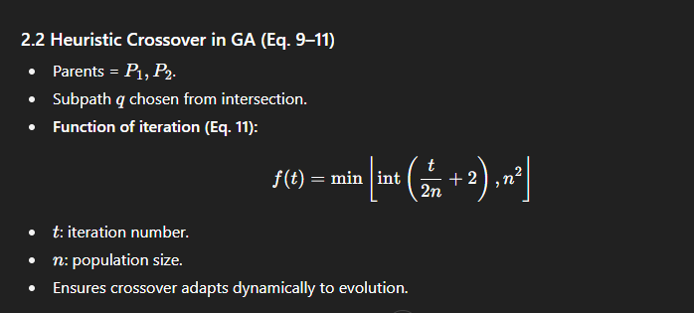

2.3 Initial Pheromone Update (Eq. 12–13)
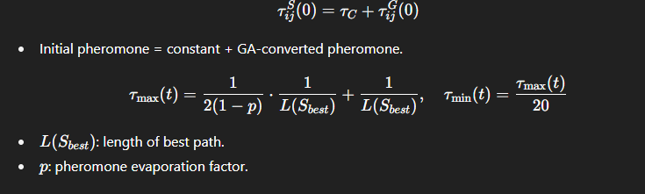

2.4 Smoothing Mechanism (Eq. 14)
- 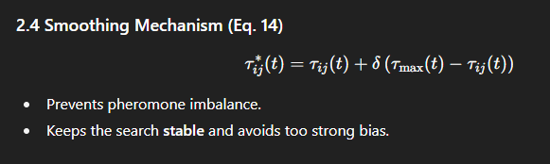Prevents pheromone imbalance.
- Keeps the search stable and avoids too strong bias.

2.5 Reward & Punishment with Diffusion (Eq. 15)
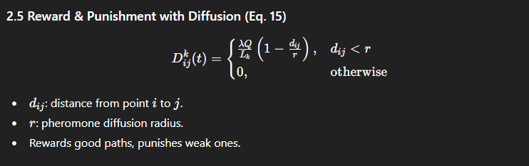

3. Algorithm Flow
- Initialize parameters (population size, pheromone values).
- Run GA: selection → crossover → mutation → evaluate fitness.
- Convert GA’s best individuals into initial pheromone values for ACO.
- Run ACO: ants move based on transition probabilities.
- Update pheromones: global update + reward & punishment + smoothing.
- Repeat until convergence.

4. Experimental Setup
- Datasets:
  - 16 cities (coordinates given, e.g., city 1 = (1280, 2132)).
  - 12 delivery points + 1 distribution center (logistics problem).
- Parameters:
  - Crossover rate = 0.6
  - Population size = 500
  - Mutation rate = 0.3
  - Info heuristic = 0.4
  - Expected heuristic = 4
- Algorithms compared: ACO, GA, GA-ACO, RA-GA-ACO.

5. Results

5.1 Path Length & Speed
- GA-ACO: path length = 14,578, time = 34s.
- ACO: 15,940, time = 45s.
- GA: 15,758, time = 116s.
👉 GA-ACO was shorter & faster.

5.2 RA-GA-ACO vs ACO in logistics (12 delivery points)
- ACO: optimal path = 109.6 km.
- RA-GA-ACO: 99.2 km (↓10.4 km).
Iterations:
- ACO = 49, GA-ACO = 42, RA-GA-ACO = 36.
Execution time:
- ACO = 9.16s, GA-ACO = 8.82s, RA-GA-ACO = 8.45s.
👉 RA-GA-ACO = fastest & shortest path.

5.3 Comparison with Advanced Algorithms (INOA & IACA-MS, 2024)
- Path length: RA-GA-ACO = 99.2 km (better than 106.7 km & 102.3 km).
- Iterations: RA-GA-ACO = 36 (fewer than 40 & 43).
- Execution time: RA-GA-ACO = 8.45s (faster).
👉 RA-GA-ACO beat even the newest 2024 algorithms.

6. Discussion
- RA-GA-ACO combines GA’s global search + ACO’s path optimization.
- Reward & punishment strategy prevents getting stuck in local optima.
- Works well in ITS scenarios (traffic planning, logistics, congestion reduction).
- Limitations: Did not consider traffic lights, road closures, accidents.

7. Conclusion
- RA-GA-ACO = faster, more stable, and more accurate than ACO, GA, GA-ACO, INOA, and IACA-MS.
- Can improve urban traffic flow, reduce congestion, and save resources.
- Has strong potential in real-world intelligent transportation systems (ITS).
- Future work → test with real maps & real traffic conditions.

✅ In short:
This paper designed RA-GA-ACO, a hybrid of Genetic Algorithm + Ant Colony with reward/punishment.
It was tested on synthetic city coordinates and logistics networks.
Equations describe how fitness, pheromones, and smoothing are updated.
Results prove RA-GA-ACO is faster, more accurate, and more efficient than other algorithms.

Do you want me to also make a one-page summary with equations + diagrams (flow + pheromone update) like lecture notes, so you can revise quickly?

Research papers

1.Detection, control and mitigation system for secure vehicular communication

Here’s a concise breakdown of the paper titled “Detection, control and mitigation system for secure vehicular communication” by Carlos Hidalgo et al. You can access the full paper on Elsevier’s repository.

🧠 Core Summary
Objective:
To enhance the security of vehicular communication systems by detecting, controlling, and mitigating cyber threats—especially in Connected Intelligent Transportation Systems (C-ITS).
Key Contributions:
- Introduces a real-time security framework based on the SerIoT project, which monitors and protects vehicular networks.
- Demonstrates how On-Board Units (OBUs) and Road Side Units (RSUs) interact securely using SerIoT’s detection and mitigation capabilities.
- Focuses on threats like Denial of Service (DoS) and data injection attacks, with rerouting and traffic flow optimization as part of the mitigation strategy.
Use Cases:
- Fleet Management: Secure coordination among vehicles.
- Smart Intersections: Dynamic rerouting and threat response using RSUs.
Validation:
Tested under simulated threat scenarios, showing SerIoT’s effectiveness in maintaining secure and uninterrupted traffic flow.

📊 Relevant Datasets for Implementation
Dataset | Description | Link
VeReMi | Benchmark dataset for VANET misbehavior detection | VeReMi GitHub
CARLA + SUMO | Urban driving simulator with traffic control | CARLA Simulator + SUMO
NS-3 VANET Modules | Network simulation for vehicular communication | NS-3 VANET GitHub
CICIDS 2017 | General intrusion detection dataset | CICIDS Dataset

🧬 Codebases & Frameworks
Repo | Description | Link
SerIoT Framework (conceptual) | No public repo found, but related EU project info | SerIoT Project Page
VANET Security Toolkit | Intrusion detection and mitigation in vehicular networks | RSU-Based IDS GitHub
SUMO-RL | RL-based traffic control with SUMO | SUMO-RL GitHub
VeReMi Evaluation Tools | Misbehavior detection benchmarking | VeReMi Tools

If you’re planning to replicate or benchmark this system, I recommend starting with the VeReMi dataset for misbehavior detection and integrating it with SUMO or CARLA for traffic simulation. Want help building a CSV schema or RL pipeline for this setup? I can sketch that out next.

2.Congestion Forecasting Using Machine Learning Techniques: ASystematic Review
Here’s a structured summary of the paper titled “Congestion Forecasting Using Machine Learning Techniques: A Systematic Review” by Mehdi Attioui and Mohamed Lahby, published in Future Transportation (2025).

🧠 Core Summary
Objective:
To systematically review machine learning (ML) techniques applied to traffic congestion forecasting between 2010 and 2024, identifying trends, gaps, and future directions.
Scope & Methodology:
- Follows PRISMA 2020 guidelines.
- Analyzed 115 peer-reviewed studies from IEEE Xplore, SpringerLink, and ScienceDirect.
- Assessed ML models, forecasting intervals, traffic parameters, and road/vehicle types.
Key Findings:
- Supervised learning dominates (57%), especially classification tasks (42%).
- Deep Neural Networks (DNNs) are the most used models (47%), followed by Graph Convolutional Networks and SVMs.
- Recurrent congestion is the primary focus (76%), with passenger vehicles being the most studied (90%).
- Short-term forecasting (minute/hourly) is preferred for real-time traffic management.
- Underexplored areas: Reinforcement learning (8%), rural roads (2%), and industry–academia collaboration (3%).
Recommendations:
- Emphasize multimodal transport, real-time adaptation, and reinforcement learning.
- Improve data diversity and collaborative frameworks for practical deployment.

📊 Suggested Datasets for Implementation
Dataset | Description | Link
PEMS-BAY | Traffic speed data from California | PEMS-BAY GitHub
METR-LA | Los Angeles traffic sensor data | METR-LA GitHub
CityFlow | Large-scale urban traffic simulator | CityFlow GitHub
T-Drive | GPS trajectories of Beijing taxis | T-Drive Dataset
OpenStreetMap (OSM) | Real-world road network data | OSM Data

🧬 Codebases & Frameworks
Repo | Description | Link
DCRNN | Deep learning for traffic forecasting | DCRNN GitHub
ASTGCN | Attention-based spatiotemporal GCN | ASTGCN GitHub
GraphWaveNet | Graph-based traffic prediction | GraphWaveNet GitHub
SUMO-RL | RL-based traffic control simulator | SUMO-RL GitHub

If you'd like, I can help you build a benchmarking pipeline or CSV schema tailored to one of these datasets. Just say the word.

3. Machine learning for predictions of road traffic accidents and spatial network analysis for safe routing on accident and congestion-prone road networks

Here’s a detailed summary of the paper titled “Machine learning for predictions of road traffic accidents and spatial network analysis for safe routing on accident and congestion-prone road networks” by Yetay Berhanu et al., published in Results in Engineering (2024).

🧠 Core Summary
Objective:
To reduce road traffic accidents (RTAs) and congestion in Addis Ababa by integrating machine learning (ML)—specifically Random Forest (RF)—with spatial network analysis to identify safe routes.
Methodology:
- Historical Data: 64,878 accident records (2014–2019) from Addis Ababa Traffic Office.
- ML Model: Random Forest used to predict accident likelihood based on road features, weather, lighting, time, and driver demographics.
- Crash Rate Analysis: Calculated crash frequency per road segment using ArcGIS tools.
- Spatial Network Analysis: Used to generate safe routes avoiding high-risk segments.
Key Results:
- RF model achieved 78% accuracy (R² = 0.78) in predicting accident-prone segments.
- Three alternative routes were generated; Route 1 was optimal with the shortest travel time (41.58 min) and lowest predicted RTAs (108).
- Safe routing was validated using both historical and predicted crash data.

📊 Datasets Used
Dataset | Description
Addis Ababa Traffic Accident Records (2014–2019) | 64,878 entries with geocoded crash locations, road attributes, and timestamps.
OpenStreetMap (OSM) | Road network data used for spatial analysis and route generation.
City Boundary & Road Shapefiles | From Addis Ababa City Roads Authority (AACRA) and Traffic Management Agency (AATMA).
These datasets are not publicly available but were obtained from local government agencies. For benchmarking, you can use similar open datasets like PEMS-BAY, METR-LA, or T-Drive.

🧬 Relevant Codebases
Repo | Description | Link
Traffic Accident Prediction and Analysis | RF-based accident prediction using Python | GitHub Repo
SUMO-RL | RL-based traffic routing simulator | SUMO-RL GitHub
GeoML Tools | Spatial ML tools for crash hotspot detection | GeoML GitHub (example repo, not from paper)

🤖 Why Machine Learning Is Used
- Complexity Handling: ML models like RF can capture nonlinear relationships between crash likelihood and multiple predictors (e.g., road type, time, weather).
- Predictive Power: RF offers high accuracy and robustness, especially with imbalanced datasets.
- Spatial Insight: ML enables hotspot mapping and proactive safety planning.

⚠️ Limitations of Machine Learning in This Context
- Data Quality: Missing or inaccurate crash records can skew predictions.
- Generalization: RF models trained on Addis Ababa data may not transfer well to other cities.
- Real-Time Constraints: Lack of real-time data limits dynamic rerouting capabilities.
- Interpretability: Ensemble models like RF are less transparent than rule-based systems.
- Infrastructure Dependence: Requires GIS tools (e.g., ArcGIS Pro) and spatially rich datasets.

Would you like a CSV schema or pipeline sketch to replicate this study using open data? I can help you build one tailored to your benchmarking workflow.
4. Deep Learning System for Vehicular Re-Routing and Congestion Avoidance
Here’s a complete breakdown of the paper titled “Deep Learning System for Vehicular Re-Routing and Congestion Avoidance” by Pedro Perez-Murueta et al., published in Applied Sciences (2019):

🧠 Summary of the Paper

🎯 Objective
To develop a predictive vehicular re-routing system that avoids traffic congestion using deep learning, specifically ConvLSTM networks, and real-time data from probe vehicles.

🚗 Key Components
- ConvLSTM-based prediction model: Forecasts traffic congestion 5 minutes ahead.
- Entropy-Balanced k Shortest Path (EBkSP) algorithm: Generates alternative routes.
- Agent-based architecture:
  - Vehicle Agent (VA)
  - Probe Car Agent (PCA)
  - Cruise Agent (CA)
  - Zone Agent (ZA)
  - Network Agent (NA)
  - Route Guidance Agent (RGA)

🧠 Where Deep Learning Is Used
- ConvLSTM (Convolutional LSTM) is used to predict spatio-temporal traffic conditions.
- It processes delay matrices generated every 300 seconds from probe car data.
- The model forecasts congestion zones, enabling proactive rerouting.

🤖 Why Deep Learning Was Used
- Traffic prediction is inherently a spatio-temporal sequence problem.
- ConvLSTM excels at capturing both spatial dependencies (road network layout) and temporal patterns (traffic flow over time).
- Traditional models (e.g., Kalman filters, fuzzy logic) lack this dual capability.

📊 Performance & Accuracy
Metric | M4 Network | M5 Network
Average Travel Time (ATT) Reduction | 19.53% | 12.20%
Waiting Time Reduction | 39.05% | 3.23%
Time Loss Reduction | 30.69% | 1.07%
ConvLSTM Accuracy | ~88% | ~88%
- Only 10% of vehicles act as probe cars.
- Up to 38% of vehicles benefit from rerouting.
- ConvLSTM architecture: 5 layers, 64 hidden states, 3×3 kernels, trained using Adam optimizer.

📂 Dataset & Simulation Tools

🧪 Synthetic Dataset
- Generated using SUMO (Simulation of Urban Mobility) and TraCI4J.
- Two grid networks: M4 (4×4) and M5 (5×5), each with 200m street segments.
- Traffic demand simulated for 24 hours with varying flow levels (LOW, MEDIUM, HIGH).
- 2400 simulations used to generate training data.

🔗 Dataset & Tool Links
- SUMO: https://www.eclipse.org/sumo/
- TraCI4J API: https://github.com/egueli/TraCI4J
- TAPASCologne scenario (for future real-data testing): http://sumo.dlr.de/wiki/Data/Scenarios/TAPASCologne

💻 Code & Implementation
- Deep learning model implemented in Keras with TensorFlow backend.
- GPU used: Dual NVIDIA GTX 1080.
- Training setup:
- model = Sequential()
- model.add(ConvLSTM2D(filters=64, kernel_size=(3, 3), return_sequences=True, input_shape=(None, 5, 5, 1)))
- model.add(BatchNormalization())
- # Repeat ConvLSTM layers as needed
- model.add(Conv3D(filters=1, kernel_size=(3, 3, 3), activation='sigmoid'))
- model.compile(optimizer=Adam(learning_rate=1e-4), loss='mse')
No public GitHub repo was linked in the paper, but the implementation is reproducible using the above setup and SUMO-generated data.

⚠️ Limitations
- Only synthetic data used; real-world validation pending.
- Requires probe cars (10% of fleet) for real-time updates.
- Forecasts are valid for only 300 seconds.
- Limited to grid-like urban layouts (Manhattan-style networks).
- No comparison with other deep models like Graph Neural Networks or Transformers.

Would you like a CSV schema for the delay matrix or a sample SUMO config to replicate the simulation setup? I can whip that up for you.
- MacroServ: A Route Recommendation Service for Large-Scale Evacuations
Here’s a detailed summary and breakdown of the paper “MacroServ: A Route Recommendation Service for Large-Scale Evacuations” by Khan et al., published in IEEE Transactions on Services Computing, Vol. 10, No. 4, 2017.

🧠 Core Idea
MacroServ is a scalable, real-time route recommendation service designed to guide evacuees during large-scale disasters (e.g., floods, earthquakes). Unlike traditional evacuation models that rely on static assumptions or optimization techniques, MacroServ dynamically simulates traffic flow using real-time data from Intelligent Transportation Systems (ITS) and roadside sensors.

🧪 Key Contributions
- Real-time route computation using dynamic traffic and disaster data.
- Parallel computing for scalability across large transportation networks.
- Probabilistic modeling of evacuee behavior using:
  - Poisson distribution for vehicle departure rates.
  - Weibull distribution for evacuee response times.
- Cost-based routing that considers congestion, speed limits, road damage, and shelter capacity.

🧮 Algorithmic Framework
- Route Cost Calculation: Based on traffic flow capacity, speed, and congestion.
- Route Recommendation Algorithm: Parallelized using MPI across subgraphs of the city map.
- Shelter Selection: Probabilistic assignment based on real-time shelter capacity and accessibility.

📊 Performance & Accuracy
Simulations were run on a real map of Fargo, ND, USA, with:
- 2,800 intersections
- 7,370 road links
- Population: 108,000

Compared Approaches:
- MacroServ
- Shortest-Path (Dijkstra)
- Dedicated Routes (predefined by city)

Results:
- Evacuation time reduced by up to 50% compared to other methods.
- Higher throughput of evacuees per minute.
- Better resilience to road damage and congestion.
- Scalability proven via Quadtree partitioning and parallel execution.

🤖 Deep Learning Usage
No deep learning models were used in this paper.
Instead, the system relies on:
- Probabilistic modeling (Poisson, Weibull, Bernoulli)
- Real-time simulation
- Parallel computing

Why not deep learning?
- The problem is modeled as a real-time decision system, not a pattern recognition task.
- Deep learning would require large labeled datasets and training time, which is impractical during emergencies.
- The authors prioritized scalability and interpretability over predictive modeling.

⚠️ Limitations
- No modeling of psychological factors like panic or non-compliance.
- Assumes sensor reliability and full ITS coverage.
- No integration of deep learning or reinforcement learning, which could improve adaptability.
- Scalability bottlenecks if partitioning is not optimal (communication overhead increases).

📂 Dataset & Code Availability
The paper uses:
- OpenStreetMap API for road network data.
- City of Fargo & NDOT for traffic volumes, speed limits, and flood history.
🔗 You can explore the paper listing on COMSATS Research Portal.
However, the code and datasets are not publicly released. You may need to contact the authors directly for access or replicate the simulation using:
- OpenStreetMap XML exports
- Synthetic traffic data
- MPI-based C++ simulation framework

Would you like a CSV schema or simulation template to replicate the routing logic? I can sketch that out for you.

- Dynamicurbantraffic rerouting with fog-cloud reinforcement learning

Here’s a comprehensive summary of the paper “Dynamic Urban Traffic Rerouting with Fog-Cloud Reinforcement Learning” by Runjia Du et al., published in Computer-Aided Civil and Infrastructure Engineering (2024)—tailored for your benchmarking-focused workflow.

🧠 Core Idea
The paper proposes a two-phase rerouting framework for urban traffic using:
- Fog-cloud architecture for scalable data processing
- Graph Attention Q-Network (GAQ) for congestion-aware decision-making
- Entropy-Balanced k Shortest Path (EBkSP) for route assignment
This hybrid system dynamically reroutes vehicles in real-time, improving traffic flow and reducing congestion.

🧪 Key Components

1. Fog-Cloud Architecture
- Fog nodes: Local data collection and preprocessing
- Cloud: Centralized learning and global optimization
- Enables decentralized execution with centralized planning

2. Deep Reinforcement Learning (DRL)
- Model: GAQ (Graph Attention Q-Network)
- Why used:
  - Handles large action space efficiently
  - Learns congestion patterns from local and neighboring regions
  - Improves adaptability to dynamic traffic conditions

3. Route Assignment
- Uses EBkSP to assign routes based on:
  - Vehicle priority (near/far from destination)
  - Route popularity (to avoid congestion shift)

🧠 Model Architecture
Component | Description
FCN Encoder | Dense(32) → Dense(32)
GAT Layer | GATConv(32) for attention-based graph embedding
Q-Network | Dense(32) → Dense(32) → Dense(64) → Dense(64)
Output Layer | Dense(5) for region-level congestion classification
Training | 800 episodes, Adam optimizer, learning rate = 1e-4
Simulation Tool | SUMO (Simulation of Urban Mobility)
Network | Manhattan, NY (287 roads, 120 intersections)

📊 Accuracy & Performance

Compared Models:
- GAQ-EBkSP (Proposed)
- GCQ-EBkSP (Baseline learning model)
- EBkSP (Rule-based)

Metrics:
- Mean travel speed
- Probability of severe congestion

Results:
- GAQ-EBkSP outperformed others by:
  - 14%–54% higher speed
  - 8%–21% lower congestion probability
- Best performance at low rerouting ratios (≤30%)
- Rule-based models suffered from congestion shift due to lack of foresight

⚠️ Limitations
- No real-world deployment: Only simulated in SUMO
- Assumes reliable fog-cloud communication
- Limited modeling of driver behavior and compliance
- Scalability depends on fog node density and placement

📂 Code & Dataset Access
- Paper PDF: Wiley Online Library
- Authors’ contact: Sikai Chen – University of Wisconsin-Madison
- Simulation tool: SUMO
- Map data: OpenStreetMap – Manhattan
No public GitHub repo was found for the code. You may replicate the framework using:
- SUMO for traffic simulation
- PyTorch or TensorFlow for GAQ implementation
- OpenStreetMap for network topology

Would you like a CSV schema for fog node configuration or a DRL training pipeline sketch? I can generate that next to help you benchmark or replicate.

- Leveraging reinforcement learning for dynamic traffic control: A survey and challenges for field implementation

Here’s a detailed summary and breakdown of the paper “Leveraging Reinforcement Learning for Dynamic Traffic Control: A Survey and Challenges for Field Implementation” by Yu Han et al., published in Communications in Transportation Research (2023):

🧠 Core Focus of the Paper
This is a comprehensive survey of how Reinforcement Learning (RL) is applied to dynamic traffic control, including:
- Traffic signal control
- Ramp metering
- Variable speed limits (VSLs)
- Vehicle motion control
It also critically examines the challenges of deploying RL in real-world traffic systems, especially the gap between simulation and reality.

🧪 Where Machine/Deep Learning Is Used & Why

✅ Use Cases:
- Traffic signal control: RL agents optimize signal timing based on traffic states.
- Ramp metering: RL adjusts on-ramp flow to prevent bottlenecks.
- VSLs: RL sets speed limits to mitigate congestion or jam waves.
- CAV merging: RL controls autonomous vehicle behavior for safe merging.

🤖 Why RL/Deep RL Is Used:
- Avoids reliance on complex, nonlinear traffic models.
- Learns directly from data or simulations.
- Reduces online computation time.
- Can adapt to real-time traffic dynamics.

🧠 Deep RL Algorithms Used:
Algorithm | Type | Use Case
DQN, Double DQN, Duel DQN | Value-based | Signal control, ramp metering
PPO, A2C | Policy-based | Multi-agent coordination
TD3 (used in their ramp metering experiment) | Actor-Critic | Continuous control actions
DDPG | Actor-Critic | CAV control, VSLs

📉 Limitations of RL in Traffic Control

🚧 Online RL:
- High learning cost due to random exploration.
- Unsafe actions during training (e.g., causing congestion).
- Needs hundreds of hours of real-world data to outperform traditional methods.

🧪 Offline RL:
- Relies heavily on simulator accuracy.
- Poor transferability to real-world traffic due to environment mismatch.
- Performance degrades if simulator doesn’t match real traffic behavior.

🧠 Accuracy & Performance:
- In their ramp metering experiment using TD3:
  - Achieved 13.7% reduction in total travel time (TTT) in simulation.
  - But performance dropped when tested in mismatched environments.
  - Compared to ALINEA (a baseline controller), RL needed ~350 rush hours to consistently outperform.

🧬 Model Name & Setup
- Model Name: TD3 (Twin Delayed Deep Deterministic Policy Gradient)
- Scenario: Local ramp metering on a real freeway stretch
- Simulator: SUMO (Simulation of Urban Mobility)
- State Variables: Mainstream flow, bottleneck density/speed, on-ramp queue
- Reward Function: Penalizes deviation from critical density

📂 Dataset & Code Availability
Unfortunately, the paper does not provide direct links to datasets or codebases. However, here are practical alternatives:

🔗 Similar Open Datasets:
- NGSIM Dataset (US Highway 101)
- PeMS (California Performance Measurement System)
- OpenTraffic
- SUMO Traffic Scenarios

💻 RL Traffic Control Codebases:
- CityFlow (multi-agent RL for traffic signals)
- Flow (RL for autonomous vehicles)
- PressLight (RL + Max Pressure)
- SUMO-RL (RL wrapper for SUMO)

🔍 Key Takeaways for Field Implementation
Challenge | Description | Proposed Solutions
Learning Cost | Unsafe exploration, slow convergence | Physics-informed RL, imitation learning
Transferability | Sim-to-real mismatch | Meta-RL, scaled testbeds
Scalability | Large state-action space | Multi-agent coordination, modular RL
Data Scarcity | Limited real-world training data | Learning from demonstration, hybrid RL

Would you like a CSV schema or pseudocode template for implementing one of these RL strategies (e.g., ramp metering or signal control)? I can tailor it to your benchmarking workflow.
- Neighbor-Aware Reinforcement Learning for Mixed Traffic Optimization in Large-scale Networks

Here’s a detailed breakdown of the paper “Neighbor-Aware Reinforcement Learning for Mixed Traffic Optimization in Large-scale Networks” by Iftekharul Islam and Weizi Li (arXiv:2412.12622)—tailored to your benchmarking-focused workflow:

🧠 Core Idea
This paper introduces a network-level reinforcement learning (RL) framework for managing mixed traffic (human-driven + robot vehicles) across large-scale urban intersections. The key innovation is a neighbor-aware reward mechanism that enables robot vehicles (RVs) to optimize local intersection efficiency while maintaining balanced distribution across the network.

🤖 Where Machine/Deep Learning Is Used & Why

✅ Use Case:
- Mixed traffic control across 17 real-world intersections in Colorado Springs, USA.

🔍 Why Deep RL:
- Traditional signal control lacks adaptability.
- Single-intersection RL fails to coordinate network-wide traffic.
- Deep RL enables decentralized, scalable, and adaptive control.

🧠 Model Used:
- Rainbow DQN (a hybrid of DQN variants: Double DQN, Dueling DQN, Prioritized Replay, etc.)
- Architecture: 3 hidden layers × 512 units
- Action space: {Stop, Go} for RVs

📊 Accuracy & Performance
Control Strategy | Avg. Waiting Time (s) | Improvement
HV-Unsignalized | 22.33 | Baseline
HV-Signalized | 10.60 | —
Local-RL (Wang et al.) | 3.52 | —
Neighbor-Aware RL | 2.14 | ↓39.2% vs Local-RL<br>↓79.8% vs HV-Signalized
- RV penetration rate: 60%
- Simulation duration: 1,500 seconds (last 1,000 used for evaluation)

⚙️ Methodology Highlights

🧩 POMDP Formulation:
- State (S): Traffic conditions across intersections
- Action (A): Stop/Go decisions for RVs
- Reward (R): Combines local efficiency, conflict avoidance, and neighbor-aware distribution

🧠 Reward Function:
R(s,a) = R_local + R_conflict + α * R_neighbor
- R_local: Encourages efficient flow
- R_conflict: Penalizes unsafe actions
- R_neighbor: Promotes balanced RV spread across intersections

📂 Dataset & Code Links
The paper does not release code or datasets directly, but here are practical alternatives:

🔗 Realistic Traffic Datasets:
- NGSIM (US Highway 101)
- PeMS (California)
- OpenStreetMap Colorado Springs
- SUMO Traffic Scenarios

💻 RL Codebases for Traffic Control:
- SUMO-RL: RL wrapper for SUMO
- CityFlow: Multi-agent RL for traffic signals
- Flow: RL for autonomous vehicles
- PressLight: RL + Max Pressure

🚧 Limitations
Challenge | Description
Scalability | Coordination across many intersections is complex
Transferability | Sim-to-real gap not fully addressed
Penetration Sensitivity | Performance depends on RV ratio (tested at 60%)
Action Simplicity | Binary action space (Stop/Go) may limit nuanced control

🔄 Future Directions (from authors)
- Hardware deployment
- Integration with inter-vehicle communication
- Expansion to traffic prediction and reconstruction frameworks

Would you like a CSV schema or pseudocode for implementing the neighbor-aware reward function or Rainbow DQN setup? I can tailor it to your benchmarking pipeline.

- Optimization-Augmented Machine Learning for Vehicle Operations in Emergency Medical Services
Here’s a detailed, implementation-ready summary of the paper “Optimization-Augmented Machine Learning for Vehicle Operations in Emergency Medical Services” by Maximiliane Rautenstrauß and Maximilian Schiffer (arXiv:2503.11848):

🧠 Core Idea
The paper proposes a Combinatorial Optimization-Augmented Machine Learning (CO-ML) pipeline to improve ambulance dispatching and redeployment in Emergency Medical Services (EMS). The goal is to minimize mean response time by learning policies that combine contextual awareness (via ML) with structured decision-making (via optimization).

🤖 Where Machine/Deep Learning Is Used & Why

✅ Use Case:
- Online dispatching and redeployment of ambulances in a centrally controlled EMS system.

🔍 Why ML Is Used:
- ML captures contextual and stochastic dynamics (e.g., future emergency call patterns).
- Optimization handles combinatorial structure (e.g., matching ambulances to requests).
- ML alone struggles with decision quality; optimization alone lacks adaptability.

🧠 Model Names:
- ML Layer:
  - Linear Regression (LR)
  - Multilayer Perceptron (MLP) with hidden layers (used for complex pattern learning)
- CO Layer:
  - Weighted Bipartite Matching problem solved via combinatorial optimization
- Training Paradigm:
  - Structured Learning using Perturbed Fenchel-Young Loss
  - Enhanced with offline MILP-generated training data and augmented datasets

📊 Accuracy & Performance

🚑 Case Study: San Francisco 911 Medical Incident Data
- Compared against industry benchmarks:
  - CICS: Closest Idle Dispatch + Closest Station Redeployment
  - CIFS: Closest Idle Dispatch + Fixed Station Redeployment

🔥 Results:
Scenario | Ambulances | Demand | Best Model | Response Time ↓
Low Demand | 25 | Night | MLP + Enhanced Data | ↓12.98% vs CICS
High Demand | 50 | Afternoon | MLP + Anticipative Data | ↓28% vs CIFS
Low Demand | 50 | Night | LR (baseline) | ↓19% vs CIFS
High Demand | 25 | Afternoon | MLP | ↓7.29% vs CICS
- Runtime savings: Up to 87.9% compared to DAGGER-style augmentation
- Utilization: Ambulances busy ~26–58% depending on scenario

⚙️ Pipeline Architecture
System State xt → ML Layer φw(xt) → Parameter θ → CO Layer g(θ) → Decision yt
- ML predicts edge weights for ambulance-request matching
- CO layer solves bipartite matching to assign ambulances
- Training uses imitation learning from MILP-generated optimal policies

📂 Dataset & Code Links

🔗 Dataset Used:
- San Francisco 911 Medical Incident Data
https://data.sfgov.org

💻 Code Availability:
- No official code released by authors (as of now)
- You can replicate using:
  - NetworkX for bipartite matching
  - PyTorch or scikit-learn for ML models
  - PuLP or Gurobi for MILP

🚧 Limitations
Limitation | Description
Data Scarcity | EMS data is sparse compared to typical ML applications
Generalization | Models trained on weekday/weekend data may overfit
Sim-to-real gap | Offline MILP assumes full information, not always realistic
Simplicity of LR | Linear models underperform in high-dimensional settings

🧬 Augmentation Strategy
- Offline MILP: Generates optimal dispatch/redeployment decisions
- Enhanced Training Set D′: Includes states from suboptimal policies to improve robustness
- Compared to DAGGER: Faster, less computationally expensive, similar performance

Would you like a CSV schema for dispatch/redeployment logs or pseudocode for the bipartite matching + ML pipeline? I can tailor it to your benchmarking workflow.
- Graph Neural Networks in Intelligent Transportation Systems: Advances, Applications and Trends

Here’s a comprehensive summary of the paper “Graph Neural Networks in Intelligent Transportation Systems: Advances, Applications and Trends” by Hourun Li et al. (arXiv:2401.00713)—tailored for your benchmarking and implementation workflow:

🧠 Core Focus
This survey reviews how Graph Neural Networks (GNNs) are applied across six key domains of Intelligent Transportation Systems (ITS):
- Traffic forecasting
- Vehicle control systems
- Traffic signal control
- Transportation safety
- Demand prediction
- Parking management
It emphasizes the spatio-temporal modeling power of GNNs, their ability to handle non-Euclidean data, and the evolution of GNN architectures from 2018 to 2023.

🤖 Where Machine/Deep Learning Is Used & Why

✅ Why GNNs Are Used:
- Traffic networks are inherently graph-structured (roads, intersections, vehicles).
- GNNs capture spatial dependencies (road connectivity) and temporal dynamics (traffic flow over time).
- Traditional ML (e.g., ARIMA, SVR) struggles with scalability and complexity.

🧠 GNN Variants Used:
GNN Type | Use Case | Why Used
ST-GCN, DCRNN, AGCRN | Traffic forecasting | Spatio-temporal modeling
GraphSAGE, GAT, GCN | Speed/time prediction | Node-level prediction, attention
Graph Transformers | Vehicle perception | Global/local feature learning
Hypergraph GNNs | Demand prediction | High-order relationships
Graph Reinforcement Learning | Signal control, routing | Decision-making over graphs

📊 Accuracy & Performance (Selected Models)
Model | Task | Dataset | Accuracy/Impact
DCRNN | Traffic flow | METR-LA | ↓15% MAE vs baselines
STSGCN | Flow prediction | PeMS | Improved localized correlation modeling
AGCRN | Node-specific forecasting | PeMSD7 | Learns hidden dependencies without pre-defined graphs
ASTGCN | Flow prediction | METR-LA | Attention-enhanced spatio-temporal accuracy
CAGRU | Speed prediction | PeMS | No historical speed needed, uses flow data
DeepTrans | Travel time | Bus ETA | Improves congestion prediction accuracy

⚙️ Model Names & Architectures
Model Name | Architecture Highlights
DCRNN | Diffusion convolution + GRU encoder-decoder
STSGCN | Localized spatio-temporal graph convolution
AGCRN | Adaptive graph + RNN for node-specific learning
ASTGCN | Attention + GCN for dynamic correlations
Graph Transformer (GTNet) | Local/global attention for 3D perception
Social-STGCNN | GCN + TCN for pedestrian trajectory prediction

📂 Dataset & Code Links

🔗 Open Datasets:
- METR-LA – Traffic speed in LA
- PeMSD7 – California freeway traffic
- ModelNet40 – 3D object data for vehicle perception
- San Francisco 911 – EMS dispatch data
- OpenStreetMap – Road network graphs

💻 Codebases:
- DCRNN
- AGCRN
- STSGCN
- ASTGCN
- Social-STGCNN
- GTNet

🚧 Limitations
Challenge | Description
Graph Construction | Often manual or heuristic; lacks generalization
Scalability | Large graphs → high memory and compute cost
Temporal Modeling | Long-term dependencies are hard to capture
Data Sparsity | Missing sensor data affects accuracy
Real-Time Deployment | GNNs can be slow for live traffic systems
Transferability | Sim-to-real gap in autonomous driving and signal control

🔮 Future Directions
- Dynamic graph learning: Automatically infer evolving traffic graphs
- Multi-modal fusion: Combine GPS, LiDAR, camera, and traffic data
- Federated GNNs: Privacy-preserving learning across cities
- Uncertainty-aware GNNs: Bayesian GNNs for safety-critical decisions

Would you like a CSV schema for traffic flow datasets or pseudocode for a spatio-temporal GNN pipeline? I can tailor it to your benchmarking setup.
- ASurvey of Route Recommendations: Methods, Applications, and Opportunities

Here’s a detailed, implementation-focused summary of the paper “A Survey of Route Recommendations: Methods, Applications, and Opportunities” by Shiming Zhang et al. (arXiv:2403.00284)—tailored to your benchmarking workflow:

🧠 Core Focus
This survey presents a comprehensive taxonomy of route recommendation methods across traditional machine learning and modern deep learning paradigms. It emphasizes applications in urban computing, covering:
- Navigation
- Tourism
- Economic routing
- Emergency evacuation
- Multi-modal transport

🤖 Where Machine/Deep Learning Is Used & Why

✅ Why ML/DL Is Used:
- Traditional search-based methods (e.g., Dijkstra, A*) are optimal but computationally expensive and not scalable.
- ML/DL models can learn from historical trajectories, user preferences, and multi-modal data to generate personalized, efficient, and adaptive routes.

🧠 Deep Learning Categories:
Category | Description | Example Models
Hybrid Models | Combine A* or Dijkstra with neural networks | ASNN-FRR, NeuroMLR
Sequence Models | Capture temporal patterns | GRU, LSTM, Transformer
Graph-based Models | Model road networks as graphs | GCN, GAT, AGCRN
Multi-modal Models | Fuse images, text, audio, weather | POIBERT, TripRec
Reinforcement Learning | Learn routing policies via interaction | cuRL, Deep IRL, DRL-TSP

📊 Accuracy & Performance
While the paper is a survey and doesn’t benchmark models directly, it cites performance improvements such as:
- GRU + attention: better prediction accuracy for personalized routes
- Transformer-based models: improved fuel-efficient routing and semantic-aware trip planning
- Graph-based models: superior spatio-temporal correlation handling in urban traffic
- RL-based models: optimized evacuation time, taxi revenue, and multi-objective routing

📂 Dataset & Code Links

🔗 Commonly Used Datasets:
- METR-LA – Traffic speed in LA
- PeMSD7 – California freeway traffic
- OpenStreetMap – Road network graphs
- SF 911 Medical Incident – Emergency routing
- Landstar Comments – Tourism sentiment data

💻 Codebases Referenced:
- DCRNN
- AGCRN
- STSGCN
- TripRec
- POIBERT
- NeuroMLR

⚙️ Model Names & Highlights
Model Name | Type | Key Feature
ASNN-FRR | Hybrid (A* + MLP) | Learns cost functions for fuel-efficient routing
NeuroMLR | Graph-based | Lipschitz embedding + GCN for trajectory modeling
TripRec | Transformer | De-biased representation learning for trip generation
POIBERT | BERT-based | Personalized itinerary generation from POI history
cuRL | Deep RL | Bi-criteria optimization (distance + user cost)
Deep IRL | RL | Learns driver preferences from GPS trajectories

🚧 Limitations
Limitation | Description
Scalability | Deep models can be slow for real-time routing
Data Sparsity | Sparse or noisy trajectory data affects accuracy
Multi-modal Fusion | Complex to integrate diverse data types (text, image, GPS)
Personalization | Hard to generalize across users with unique preferences
Sim-to-Real Gap | RL models trained in simulation may fail in live traffic

🔮 Future Opportunities
- Federated route learning: privacy-preserving personalization
- Contrastive trajectory learning: better representation of user intent
- Multi-agent RL: collaborative routing in shared mobility
- Integration with LLMs: semantic-aware trip planning

Would you like a CSV schema for trajectory logs or pseudocode for a hybrid A* + GNN routing pipeline? I can tailor it to your benchmarking setup.
- A Review on Machine Learning in Intelligent Transportation Systems Applications
Here’s a detailed, implementation-ready summary of the paper “A Review on Machine Learning in Intelligent Transportation Systems Applications” by Abul Kalam Azad et al. (Open Transportation Journal, 2024)—tailored to your benchmarking workflow:

🧠 Core Focus
This survey reviews 48 recent ML/DL-based proposals across 11 key ITS applications, grouped into four categories:
- Traffic Management
- Safety Management
- Infotainment & Comfort
- Autonomous Driving
It highlights the algorithms used, their performance, and open challenges, offering a roadmap for future ITS research.

🤖 Where Machine/Deep Learning Is Used & Why

✅ Why ML/DL Is Used:
- To handle large-scale, heterogeneous, real-time data from sensors, vehicles, and infrastructure.
- To improve prediction accuracy, decision-making, and automation in dynamic traffic environments.

🧠 Common ML/DL Models Used:
Model Name | Application | Why Used
GCN + LSTM | Traffic flow prediction | Captures spatial-temporal dependencies
CNN + LSTM + Attention | Traffic flow & congestion | Combines spatial features with time-series modeling
Autoencoder + SVR | Speed prediction | Feature fusion from heterogeneous sources
GRU | Travel time prediction | Efficient sequence modeling
Q-learning, A2C, Meta RL | Traffic signal control | Adaptive decision-making
RF, DT, KNN | Smart parking | Fast, interpretable predictions
YOLOv3, CRNN | Automatic tolling | Real-time license plate detection
CNN, DNN | Crash risk prediction | High accuracy in complex conditions
Dilated CNN | Pothole detection | Preserves resolution, reduces false positives

📊 Accuracy & Performance Highlights
Application | Best Model | Accuracy / Impact
Traffic Flow Prediction | CNN-LSTM-Attention | ↑ Accuracy with weather features
Speed Prediction | Autoencoder + SVR | Best among SVR, ANN, KNN
Travel Time | GRU (Porto dataset) | MAPE = 0.070%
Signal Control | Q-learning | ↓ Mean delay by 40%
Smart Parking | RF | 99.01% accuracy
Tolling (ALPR) | YOLOv3 | 95.05% accuracy, 119ms latency
Crash Risk | DNN | 68.95% accuracy, AUC = 0.641
Pothole Detection | Dilated CNN | Better precision than YOLOv5

📂 Dataset & Code Links

🔗 Datasets Mentioned or Used:
- METR-LA – Traffic speed
- PeMSD7 – California freeway
- Porto Taxi Trajectories – Travel time
- Birmingham Parking Sensors – Smart parking
- Stanford Car Dataset – Tolling
- NGSIM – Collision prediction
- CCPD – License plate detection

💻 Codebases for Replication:
- DCRNN
- AGCRN
- YOLOv3
- ImageAI (ANPR)
- SUMO-RL

🚧 Limitations Identified
Challenge | Description
Data Quality | Noisy, sparse, or imbalanced datasets
Scalability | Deep models struggle with large networks
Real-Time Constraints | High latency in DL models
Transferability | Sim-to-real gap in RL and perception models
Interpretability | DL models lack transparency for safety-critical tasks
Generalization | Overfitting to specific cities or conditions

🔮 Future Research Opportunities
- Federated ML for ITS: Privacy-preserving learning across cities
- Meta RL for signal control: Fast adaptation to new intersections
- Multi-modal fusion: Integrating weather, video, GPS, and sensor data
- Explainable AI: For safety-critical applications like crash prediction

Would you like a CSV schema or pseudocode for traffic flow prediction or smart parking occupancy modeling? I can tailor it to your benchmarking pipeline.

- Multiple-Junction-Based Traffic-Aware Routing Protocol Using ACOAlgorithm in Urban Vehicular Networks
Here’s a detailed, implementation-ready summary of the paper “Multiple-Junction-Based Traffic-Aware Routing Protocol Using ACO Algorithm in Urban Vehicular Networks” by Seung-Won Lee et al., published in Sensors (2024)—tailored to your benchmarking workflow:

🧠 Core Idea
The paper proposes MJTAR (Multiple-Junction-Based Traffic-Aware Routing), a novel routing protocol for urban VANETs (Vehicular Ad-hoc Networks). It improves upon GyTAR by:
- Considering traffic density across two-hop junctions
- Using Ant Colony Optimization (ACO) to select optimal multi-junction paths
- Operating infrastructure-free, without RSUs

🧠 Where Machine/Deep Learning Is Used & Why

✅ ML/AI Usage:
- ACO Algorithm: Inspired by ant foraging behavior, used to probabilistically select optimal junctions based on:
  - Traffic density (via pheromone simulation)
  - Proximity to destination
- No deep learning models are used directly, but the protocol mimics intelligent behavior via swarm intelligence.

🔍 Why ACO:
- Handles dynamic urban traffic efficiently
- Avoids local maxima and packet loss
- Balances exploration (new paths) and exploitation (high-density routes)

🧬 Model Name & Mechanism
Component | Description
MJTAR | Routing protocol combining traffic awareness + ACO
E-IFTIS | Enhanced Infrastructure-Free Traffic Info System (estimates traffic up to 2-hop junctions)
OMSS | Optimal Multi-Junction Selection Scheme (ACO-based)
CPP Packets | Cell Pheromone Packets used to simulate traffic density
Ant Metrics Table | Stores pheromone values, proximity scores, and route probabilities

📊 Accuracy & Performance

🧪 Simulation Setup:
- Tools: NS-3 + SUMO
- Area: 3000×2400 m² urban grid
- Compared Protocols: GSR, GyTAR, MJTAR

🚀 Results:
Metric | MJTAR | GyTAR | GSR
Packet Delivery Ratio | ↑ >20% vs GyTAR & GSR
End-to-End Delay | ↓ <1.3 seconds (avg)
Byte Overhead | Lower than GyTAR due to efficient junction selection

📂 Dataset & Code Links
The paper does not release code or datasets, but here are practical alternatives:

🔗 Open Datasets:
- OpenStreetMap – Urban road networks
- NGSIM – Real traffic flow
- SUMO Scenarios – Urban mobility models

💻 Codebases for Replication:
- SUMO-RL – RL-based traffic routing
- ACO Routing in NS-3 – Extendable for MJTAR logic
- VANET Simulation Framework – OMNeT++ + SUMO integration

🚧 Limitations
Limitation | Description
Computational Overhead | Two-hop junction analysis increases processing time
Scalability | Extending to 3+ junctions degrades performance
Sparse Traffic | Low vehicle density reduces pheromone accuracy
No DL Integration | No learning-based adaptation to traffic patterns

🔮 Future Directions
- Integrate deep reinforcement learning for adaptive junction selection
- Use hybrid RSU + E-IFTIS for off-peak traffic estimation
- Extend to multi-agent coordination in dense urban grids

Would you like a CSV schema for CPP packet logging or pseudocode for the OMSS + ACO routing logic? I can tailor it to your benchmarking pipeline.
- DYNAMIC TRAFFIC RE-ROUTING AS A METHOD OF REDUCING THE CONGESTION LEVEL OF ROAD NETWORK ELEMENTS

Here’s a detailed, implementation-focused summary of the paper “Dynamic Traffic Re-Routing as a Method of Reducing the Congestion Level of Road Network Elements” by Novikov Aleksandr et al., published in Journal of Applied Engineering Science (2018):

🧠 Core Idea
The paper proposes a Dynamic Traffic Re-Routing (DTR) method within Intelligent Transportation Systems (ITS) to reduce congestion by:
- Detecting deteriorating traffic conditions before full congestion forms
- Redirecting vehicles to alternative routes based on simulation thresholds
- Using traffic flow phase diagrams to determine when and where rerouting is effective

⚙️ Model Name & Mechanism
Component | Description
DTR Protocol | Traffic rerouting method based on congestion thresholds
Traffic Flow Phase Model | Uses Kerner’s three-phase theory: Free → Synchronized → Jam
Threshold Detection | Initiates rerouting when v/c ratio exceeds critical values
Simulation Tool | AIMSUN used to model traffic flow and rerouting impact

🤖 Where Machine/Deep Learning Is Used
- No machine or deep learning models are used in this paper.
- Instead, the approach relies on simulation-based traffic modeling and empirical threshold analysis.
- The decision logic is rule-based, not learned from data.

📊 Accuracy & Performance

🚦 Simulation Results (Rostov-on-Don Network):
% of Traffic Rerouted | Reduction in Congested Sections
0% | 20% of network congested
10% | 17%
20% | 9%
30% | 4% (optimal)
40% | 8% (reverse congestion effect)
- Optimal rerouting volume: ~30% of traffic
- Travel time reduction: Up to 50% during peak congestion
- v/c ratio improvement: From 0.53 to 0.49

📂 Dataset & Code Availability
The paper does not provide public datasets or code, but here are practical alternatives for replication:

🔗 Open Datasets:
- NGSIM – Real traffic flow data
- PeMS – California freeway sensor data
- OpenStreetMap – Road network topology

💻 Simulation Tools:
- AIMSUN – Used in the paper for traffic modeling
- SUMO – Open-source alternative for DTR simulation
- MATSim – Agent-based traffic simulation

🚧 Limitations
Limitation | Description
No ML/DL Integration | No adaptive learning or prediction
Static Thresholds | Rerouting decisions based on fixed v/c ratios
Alternative Route Saturation | Over-rerouting can cause reverse congestion
Infrastructure Dependency | Requires ITS architecture and real-time traffic data
No Real-Time Feedback | Simulation-based, not live adaptive control

🔮 Future Directions
- Integrate machine learning for predictive congestion detection
- Use reinforcement learning for adaptive rerouting policies
- Combine multi-agent simulation with real-time sensor data
- Develop hybrid DTR + signal control strategies

Would you like a CSV schema for logging rerouting decisions or pseudocode for threshold-based DTR logic? I can tailor it to your benchmarking pipeline.
[Journal of Applied Engineering Science – Full Paper](file:///E:/akhand_sir_research_topic/multiple_junction_based_traffic_aware.pdf)
- Dynamic adaptive vehicle re-routing strategy for traffic congestion mitigation of grid network
Here’s a detailed, implementation-focused summary of the paper “Dynamic Adaptive Vehicle Re-Routing Strategy for Traffic Congestion Mitigation of Grid Network” by Chen Wang, Travis Atkison, and Hana Park (International Journal of Transportation Science and Technology, 2024)—tailored to your benchmarking workflow:

🧠 Core Idea
The paper proposes a simulation-based congestion detection and re-routing strategy for grid-like urban traffic networks. It uses traditional surveillance camera data and avoids reliance on GPS or modern infrastructure. The key innovation is a dynamic congestion thresholding mechanism combined with a modified k-shortest path (kSP) algorithm for adaptive vehicle re-routing.

🧬 Model Name & Architecture
Component | Description
Dynamic Adaptive Re-Routing Model | MATLAB-based simulation using traffic volume + vehicle speed
Modified kSP Algorithm | Calculates rerouting cost based on turns, travel time, and congestion
Broadcasting System | Alerts nearby vehicles about congestion using camera-derived metrics
Congestion Detection | Based on dynamic thresholds using Box-Whisker plots of speed and volume
Simulation Tools | MATLAB Driving Scenario Designer + OpenTrafficLab

🤖 Where Machine/Deep Learning Is Used
- No deep learning models are used.
- The system uses rule-based logic, statistical modeling (e.g., Poisson distribution for vehicle entry), and optimization techniques (Nelder–Mead method for travel time estimation).
- The congestion detection is based on image-derived traffic metrics, not learned models.

📊 Accuracy & Performance

🚦 Simulation Setup:
- Grid size: 4×4 and 6×6 networks
- Vehicle injection rate (VIR): 50–200, 450–650, 1000–1500 veh/h
- Compared against: DSP, RkSP, EBkSP, TLATk, and no re-routing

🚀 Results:
VIR (veh/h) | Avg. Congestion Duration (s) | Compared to Others
50–200 | 18.83 | ↓10.78s vs no rerouting
450–650 | 32.66 | ↓26.75s vs no rerouting
1000–1500 | 54.06 | ↓26.94s vs no rerouting
- Travel speed: ~73% of speed limit (17.93 m/s vs 24.58 m/s)
- Travel time reduction: Most vehicles showed improved time; some exceptions due to rerouting overhead

📂 Dataset & Code Availability
The paper does not release code or datasets, but here are practical alternatives:

🔗 Datasets:
- OpenStreetMap – Grid network topology
- NGSIM – Real traffic flow
- PeMS – California freeway sensor data

💻 Simulation Tools:
- MATLAB Driving Toolbox
- OpenTrafficLab
- SUMO – Open-source alternative
- Veins – OMNeT++ + SUMO integration

🚧 Limitations
Limitation | Description
No ML/DL Adaptation | No predictive modeling or learning-based optimization
Passive Re-Routing | Works only if vehicles opt-in (e.g., navigation apps)
Computational Overhead | Long simulation time due to script complexity
Localized Congestion | Re-routing starts one segment before congestion—may be too late
No Signal Control | Cannot adjust traffic lights or speed limits dynamically

🔮 Future Directions
- Integrate backpropagation-based optimization for smarter rerouting
- Extend to ultra-short-term congestion forecasting
- Combine with active traffic control systems (e.g., SCOOT, SCAT)
- Explore multi-agent coordination and real-time adaptive routing

Would you like a CSV schema for logging vehicle routes and congestion events, or pseudocode for the modified kSP-based rerouting logic? I can tailor it to your benchmarking pipeline.
- Improving the performance of a traffic system by fair rerouting of travelers

Here’s a detailed, implementation-focused summary of the paper “Improving the Performance of a Traffic System by Fair Rerouting of Travelers” by Oskar A. L. Eikenbroek, Georg J. Still, and Eric C. van Berkum (European Journal of Operational Research, 2022)—tailored for your benchmarking workflow:

🧠 Core Idea
The paper introduces a social routing strategy that improves traffic system efficiency by rerouting a small fraction of travelers to slightly longer paths. The key innovation is a fairness-aware bilevel optimization model that:
- Minimizes total travel time (system optimum)
- Ensures limited detours for compliant users (fairness constraint)
- Anticipates behavioral responses from both compliant and selfish travelers

🧬 Model Name & Architecture
Component | Description
Mixed Equilibrium Model | Combines selfish (user equilibrium) and compliant (social routing) behavior
Bilevel Optimization Problem (BL) | Upper level: authority selects routes; lower level: travelers respond
Parametric Optimization Q(ρ) | Lower-level convex program modeling route choices
Directional Derivative-Based Descent Algorithm | Solves BL using sensitivity analysis of Q(ρ)

🤖 Where Machine/Deep Learning Is Used
- No machine or deep learning models are used.
- The approach is entirely optimization-based, using:
  - Variational analysis
  - Parametric sensitivity
  - Convex quadratic programming
This makes it highly interpretable and suitable for integration into centralized traffic management systems.

📊 Accuracy & Performance

🚦 Simulation Results:
- Network Type: Static traffic assignment on realistic networks
- Compliance Rate: Only a small fraction of travelers need to comply
- Travel Time Reduction: Substantial decrease in total system travel time
- Fairness Guarantee: Maximum detour per traveler is bounded by ε (indifference band)
The strategy achieves near-system-optimal performance while maintaining route acceptability for users.

📂 Dataset & Code Availability
The paper does not release code or datasets, but here are practical alternatives:

🔗 Datasets:
- NGSIM – Real traffic flow data
- PeMS – California freeway sensor data
- OpenStreetMap – Road network topology

💻 Tools for Replication:
- MATSim – Agent-based traffic simulation
- SUMO – Open-source traffic simulator
- Gurobi or CPLEX – Solvers for bilevel optimization
- Python Pyomo – Modeling bilevel programs

🚧 Limitations
Limitation | Description
No Dynamic Routing | Static assignment only; dynamic extension suggested as future work
No ML Integration | No predictive modeling or adaptive learning
Complexity | Bilevel optimization is computationally intensive
Non-Unique Solutions | Multiple route flows can yield same link flow, complicating descent direction
Compliance Assumption | Assumes travelers accept small detours (ε-band), which may vary in reality

🔮 Future Directions
- Extend to dynamic traffic assignment
- Integrate machine learning for demand prediction
- Develop real-time adaptive routing services
- Explore multi-agent coordination and incentive mechanisms

Would you like a CSV schema for logging route advice and compliance rates, or pseudocode for the bilevel optimization + descent algorithm? I can tailor it to your benchmarking pipeline.

